1. List the permissions in your current directory, including hidden files.

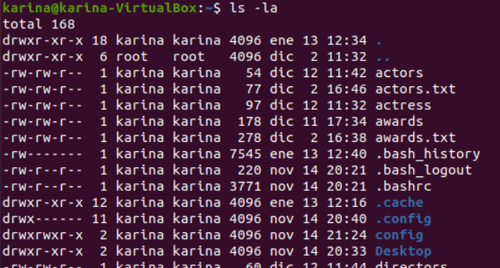

2. Create a file called perm1. Now, check the default permissions and user and group
ownership

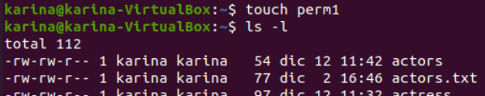
Specify the command in all possible ways.

3. Change permissions of perm1 so that everyone can read and only the owner user can write.
Specify the command in all possible ways.
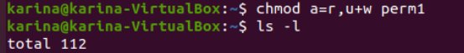

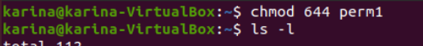

4. Create a file called script1.sh, including the content below. List the default permissions.
#!/bin/bash
clear
who
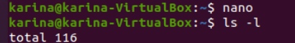

5. Remove the read permission from the owner and try to open the file

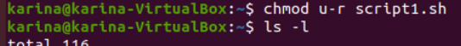

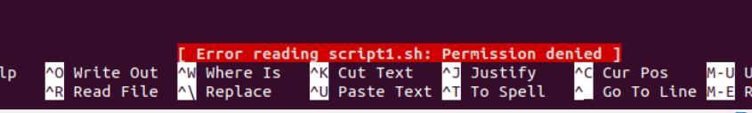
6. Remove the write permission from the owner on the file script.sh. Add the line below. Is it
possible? Why? It not possible because the user do not have read and write permissons

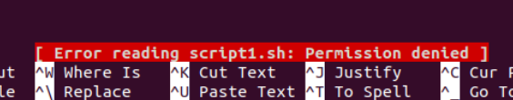

7. Change the permissions on the file script1.sh so that the owner can read, write and
execute, but you deny all the permissions from the group and others.

8. Add the line indicated in exercise 6, in case it was not possible. Try to run the file like a
command.


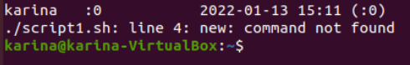

9. Remove the read permission from the owner on the file script1.sh. Try to run the file. Is it
possible?

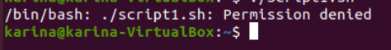

10. Create a directory called “systems”. Remove the write permission from it and try to copy
script1.sh inside.

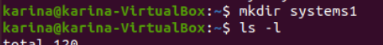

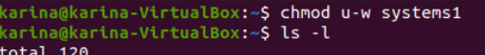

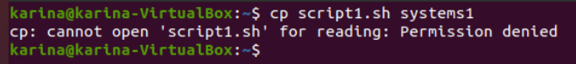
11. If you were not able to copy the file, add the write permission again and copy the file inside.

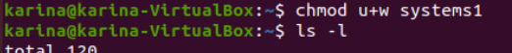

We cannot copy the file because we remove before the Read permisson on script1

we can add the permisson:

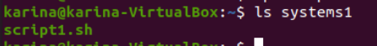

12. Remove the read permission from the user on the directory “systems” and try to list its
contents.

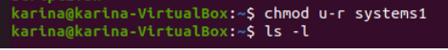

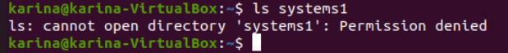

13. Change the permissions from “sytems” so that the owner can read, write and execute, but
the group and others can only read.

14. Remove the execute permission from “systems”. Can you execute systems/script1.sh? Is it
possible to acces the directory to execute the file?

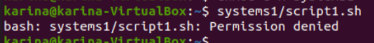

It is not possible because we remove execute permisson

15. Assign the execute permission to the directory again

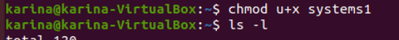

16. Create two files called “lucy” and “charles” into “systems”. Change permissions of “charles”,
so that others can write and execute.

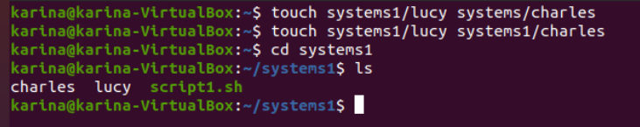

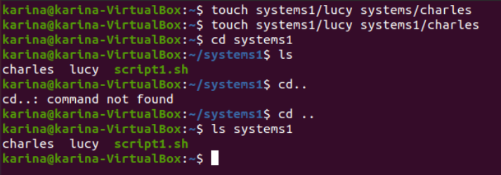
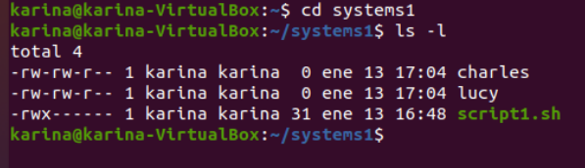

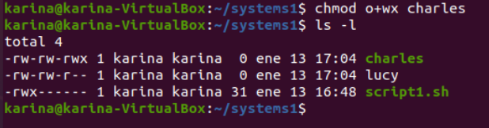
17. Change permissions of “lucy” so that the owner can read and execute, the group can read
and write and others can only write. Specify the command in all possible ways.

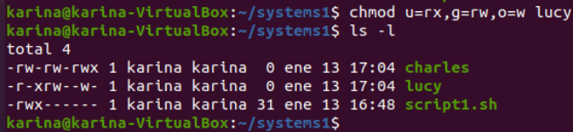
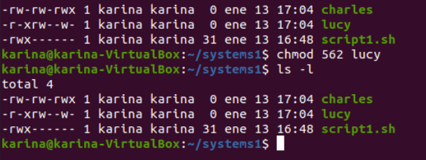

18. Log in as root. Change the ownership of “charles” to “root”. Exit the root session. Now, try to
change the permission so that others cannot read and execute. Is it possible? Why?

